WEEK – 2

Exercise 2: Verifying Interactions

Nipuna.A

Superset: 6432842

Scenario:

You need to ensure that a method is called with specific arguments.

Steps:

1. Create a mock object.
2. Call the method with specific arguments.
3. Verify the interaction.

Solution Code:

import static org.mockito.Mockito.*;

import org.junit.jupiter.api.Test; import org.mockito.Mockito;

public class MyServiceTest { @Test

public void testVerifyInteraction() {

ExternalApi mockApi = Mockito.mock(ExternalApi.class); MyService service = new MyService(mockApi); service.fetchData();

verify(mockApi).getData();

}

}

import org.junit.jupiter.api.Test; import org.mockito.Mockito;

public class MyServiceTest { @Test

public void testVerifyInteraction() {

ExternalApi mockApi = Mockito.mock(ExternalApi.class); MyService service = new MyService(mockApi); service.fetchData();

verify(mockApi).getData();

}

}

Solution:

* Src

Main\java\com\example

1)ExternalApi.java:

package com.example;

public interface ExternalApi {

    void getData();

}

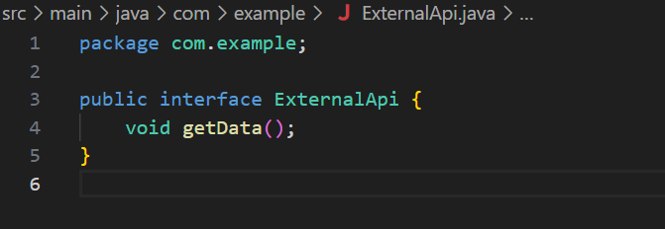

2)MyService.java

package com.example;

public class MyService {

    private ExternalApi externalApi;

    public MyService(ExternalApi externalApi) {

        this.externalApi = externalApi;

    }

    public void fetchData() {

        externalApi.getData();

    }

}

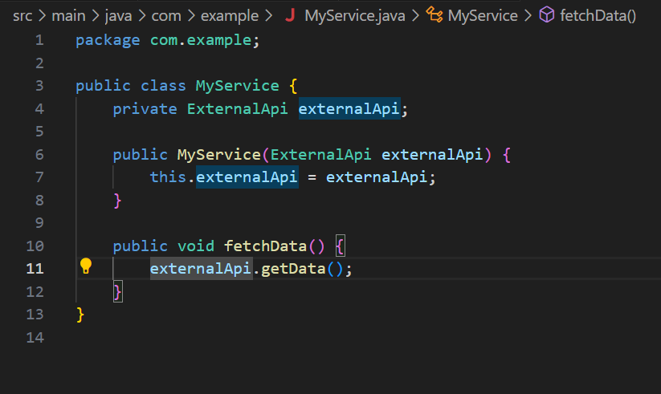

Test\java\com\example

1)MyServiceTest.java

package com.example;

import org.junit.jupiter.api.Test;

import org.mockito.Mockito;

import static org.mockito.Mockito.*;

public class MyServiceTest {

    @Test

    public void testVerifyInteraction() {

        ExternalApi mockApi = Mockito.mock(ExternalApi.class);

        MyService service = new MyService(mockApi);

        service.fetchData();

        verify(mockApi).getData();

    }

}

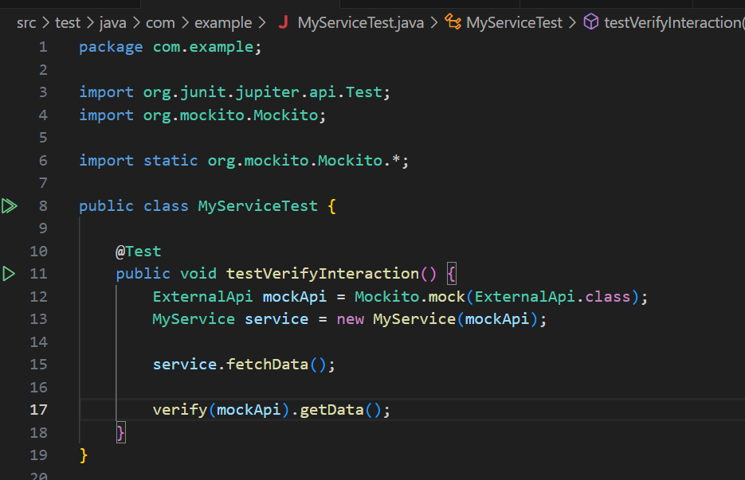

Pom.xml:

<project xmlns="http://maven.apache.org/POM/4.0.0"

         xmlns:xsi="http://www.w3.org/2001/XMLSchema-instance"

         xsi:schemaLocation="http://maven.apache.org/POM/4.0.0

                             http://maven.apache.org/xsd/maven-4.0.0.xsd">

    <modelVersion>4.0.0</modelVersion>

    <groupId>com.example</groupId>

    <artifactId>MockingAndStubbingExample</artifactId>

    <version>1.0-SNAPSHOT</version>

    <dependencies>

        <!-- JUnit 5 -->

        <dependency>

            <groupId>org.junit.jupiter</groupId>

            <artifactId>junit-jupiter</artifactId>

            <version>5.10.0</version>

            <scope>test</scope>

        </dependency>

        <!-- Mockito -->

        <dependency>

            <groupId>org.mockito</groupId>

            <artifactId>mockito-core</artifactId>

            <version>5.11.0</version>

            <scope>test</scope>

        </dependency>

    </dependencies>

    <build>

        <plugins>

            <!-- Maven Surefire Plugin for JUnit 5 -->

            <plugin>

                <groupId>org.apache.maven.plugins</groupId>

                <artifactId>maven-surefire-plugin</artifactId>

                <version>3.1.2</version>

                <configuration>

                    <includes>

                        <include>**/*Test.java</include>

                    </includes>

                </configuration>

            </plugin>

        </plugins>

    </build>

</project>

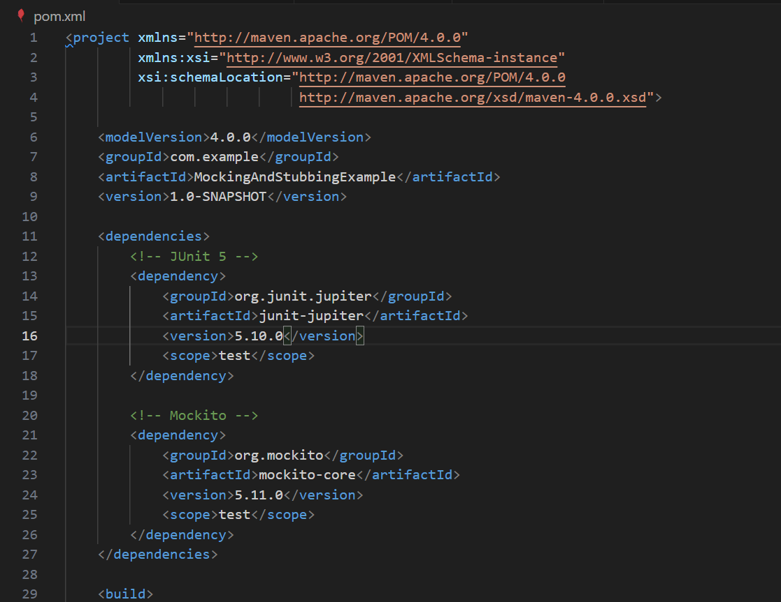

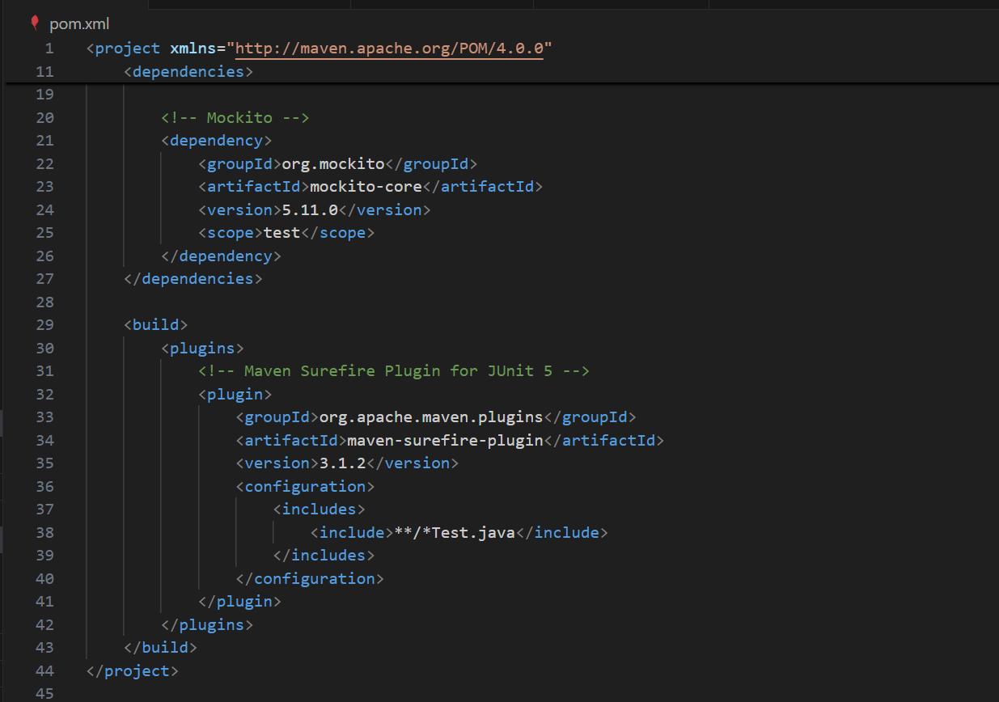

Output:

